**A REPORT ON**

**Driver for I2C SENSOR INA219**

BY

**ILLURU SAHITHYA 2020H1400247H**

**CHIDARA SINDHUJA 2020H1400251H**

**M.E. EMBEDDED SYSTEMS**

Prepared in fulfilment of the

**(EEE G547)**

**Device Drivers**



**BIRLA INSTITUTE OF TECHNOLOGY & SCIENCE, PILANI**

**(December 2021)**

**SUMMARY**

INA 219 current sensor connected with Raspberry pi using I2C interface to measure shunt current and voltage. In this project 100 ohms resistor is used as shunt and led is used as load.

**Sensor – INA219**

* The INA219 is a current shunt and power monitor with an I 2C- or SMBUS-compatible interface.
* This INA 219 sensor senses shunt voltage along with bus supply voltage with conversion times that can be programmed and filtered.
* Current is measured through a programmable calibration value, with an multiplier connected internally and it requires an additional multiplying register to measure power.

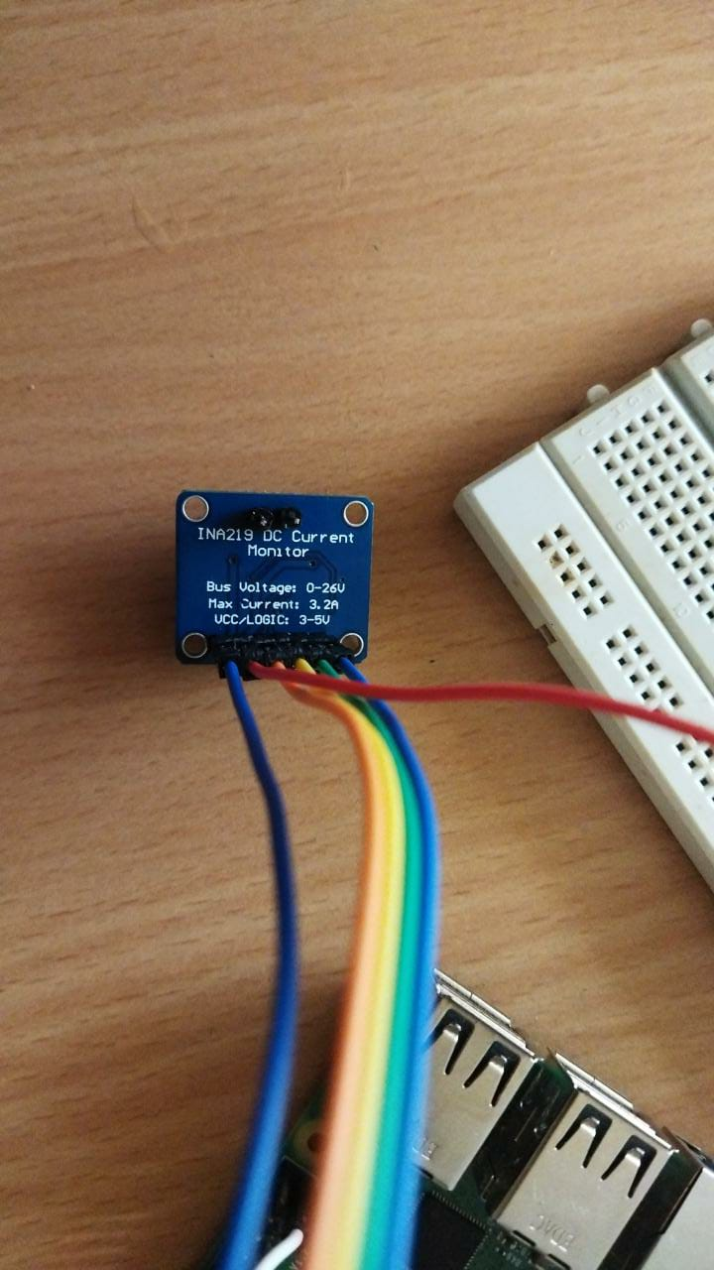

. INA 219

* The supply voltage for this sensor can range between 3 to 5.5V with maximum current drawn being 1 mA.
* INA 219 operating temperature ranges from -40C to 125C
* It has I2C interface features with 16 programmable addresses.

**SIMPLIFIED SCHEMATIC**

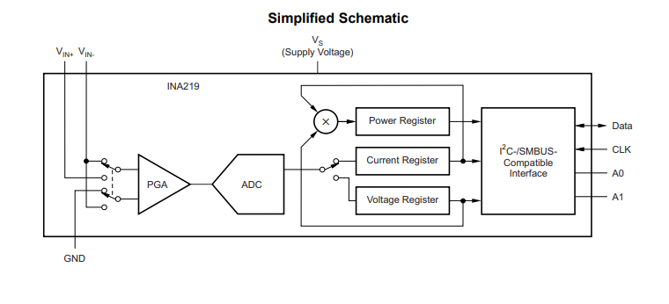

**PIN DIAGRAM AND CONFIGURATION**

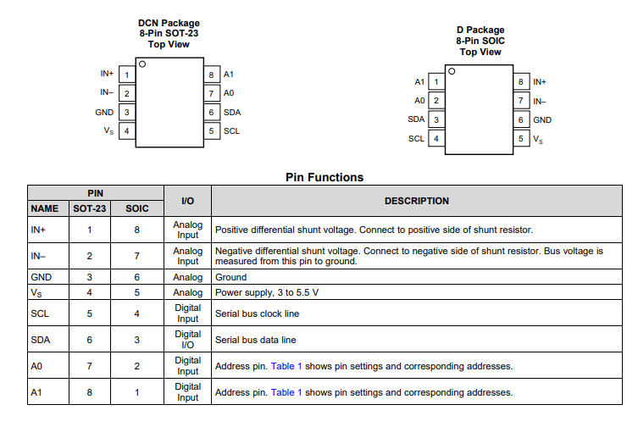

**FUNCTIONAL BLOCK DIAGRAM**

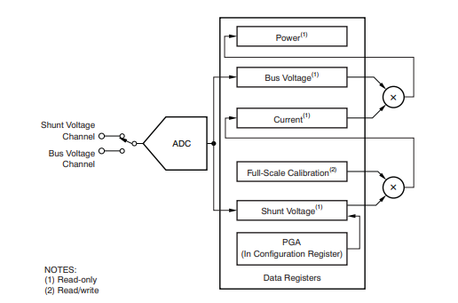

* The INA219 is a digital current sense amplifier with an I 2C- and SMBus-compatible interface. It can measure digital current, voltage, and power readings necessary for precisely-controlled systems

**Programming the Calibration Register:**

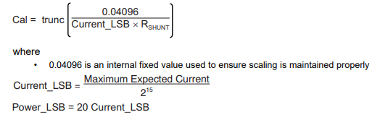

**HARDWARE DESIGN**

**Schematic Diagram**

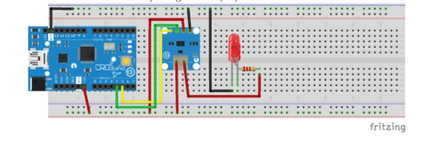

**Actual Circuit With Raspberry Pi and INA219**

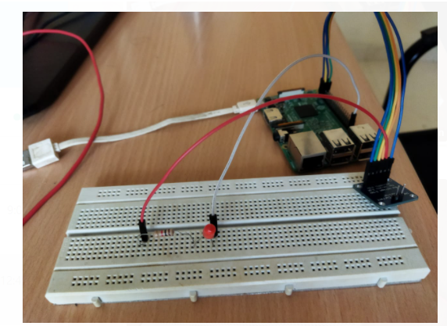

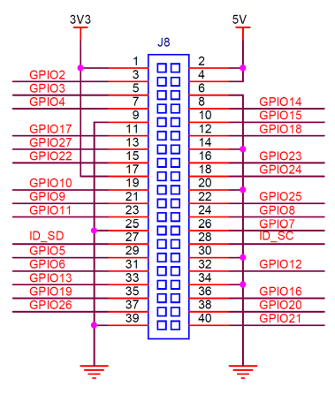

Pin Diagram of Raspberry Pi

The connections are as follows:

* 3.3V of Raspberry pi is connected to the Vdd pin of INA219
* Gpio2 of Raspberry Pi is connected to the SDA pin of INA219.
* Gpio3 of Raspberry Pi is connected to the SCL pin of INA219.
* Vin- of INA219 to shunt resistor
* Shunt resistor in series with led
* Led negative to gnd of Raspberry pi
* Vin+ of INA219 to 5v of Raspberry pi
* Gnd of INA219 to Gnd of Raspberry pi

**PROCEDURE TO BUILD AND INSERT DRIVER IN KERNEL AND TO USE USERSPACE**

**Step-1 :** Change path of the system to the directory where all the required driver files are stored using the following command

***cd path_address***

**Step-2** : Now here Makefile consists of creating object files, kernel object file and compiling userspace application. Following Command is used

***sudo make all***

**Step-3 :** In this step , we insert the driver in kernel using the following command

***sudo insmod main.ko***

**Step-4:** To run and create output file in user space the following command is used.

***gcc -o output user.c***

**Step-5:** As userspace application program is compiled in Makefile so we directly see the output of userspace program using following command

***sudo ./output***

**Step-6 :** To remove the driver from the kernel use the following command

***sudo rmmod main.ko***

**Step-7 :** To remove the object files use the following command

***sudo make clean***

**KERNEL SPACE DRIVER CODE & BUILD PROCESS:**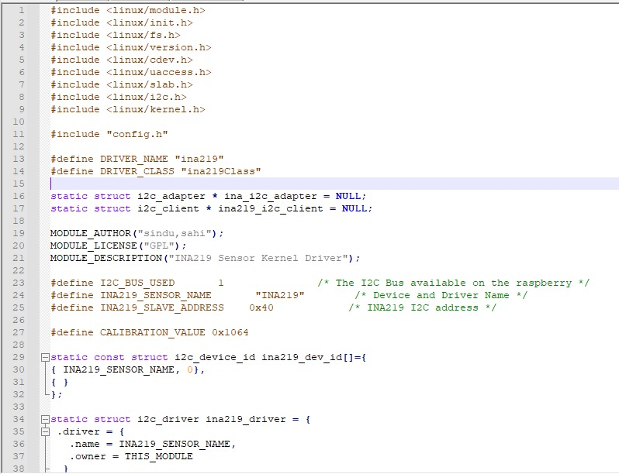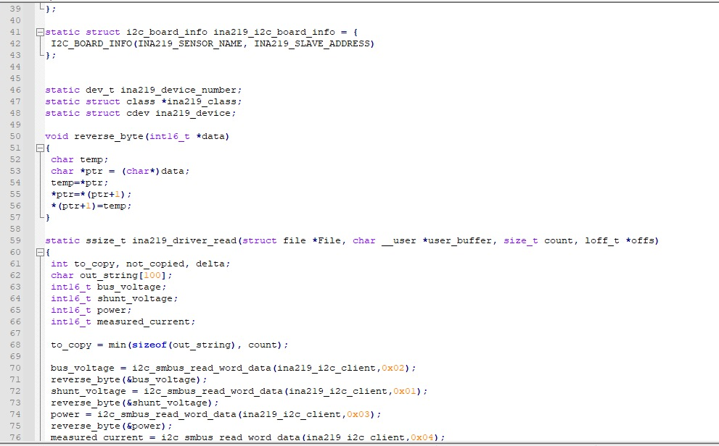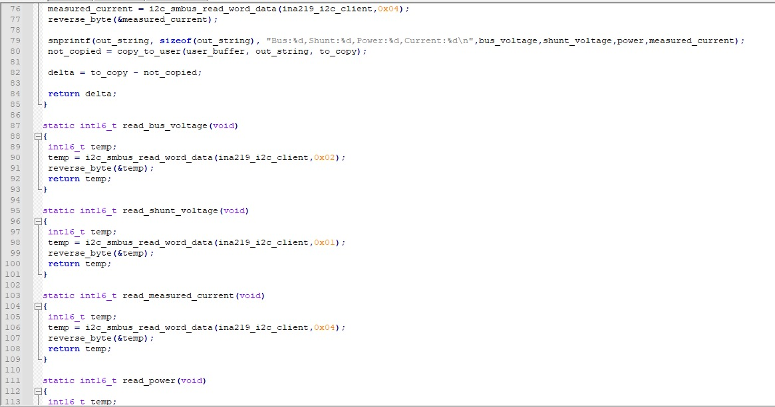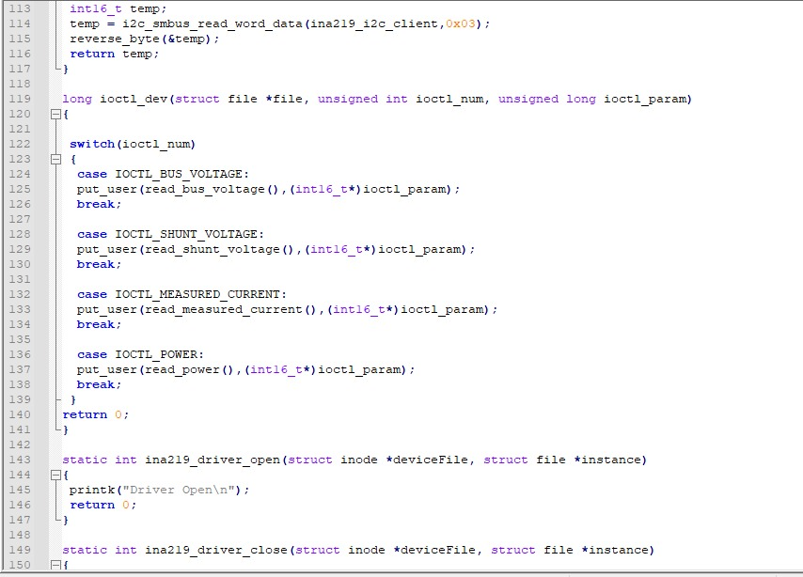

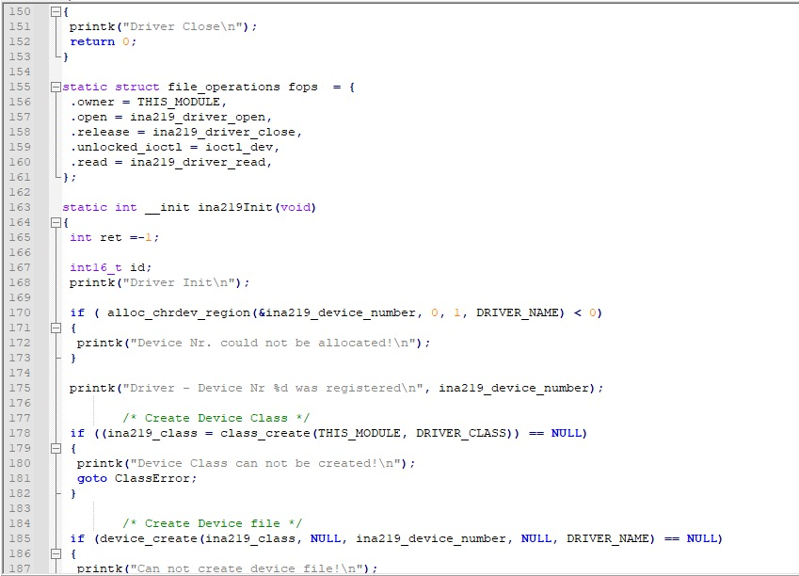

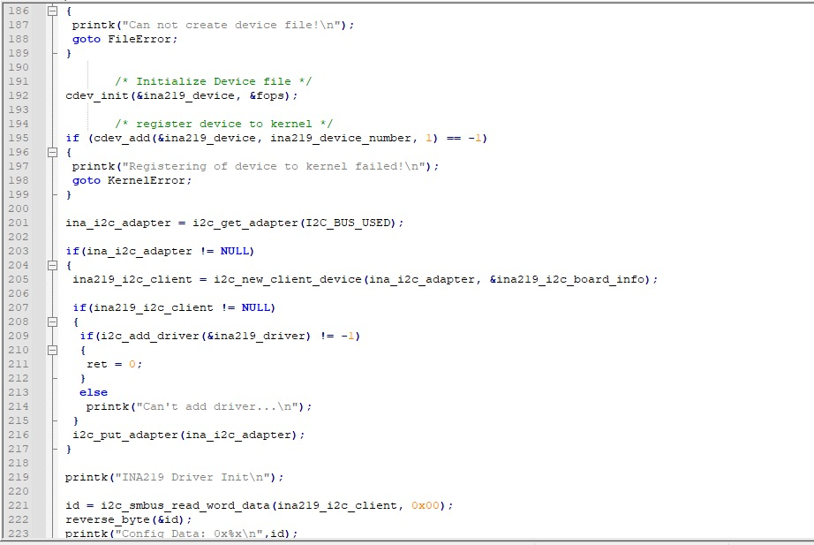

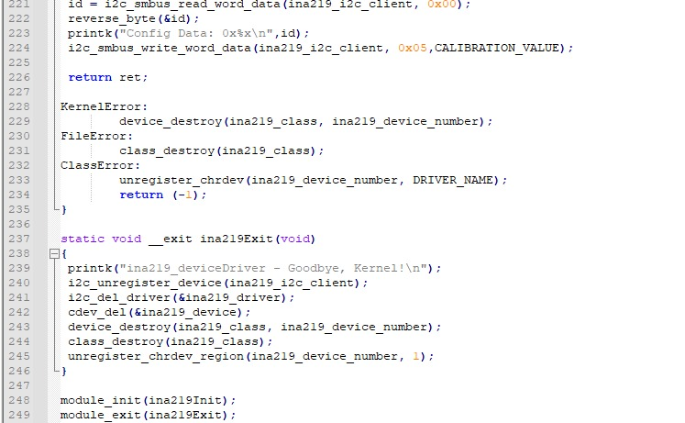

**Build Process :**

* Build the driver by using Makefile (sudo make)
* Load the driver using sudo insmod driver.ko
* Check whether module is inserter in kernel space with lsmod.

**USER SPACE APPLICATION CODE & BUILD PROCESS:**

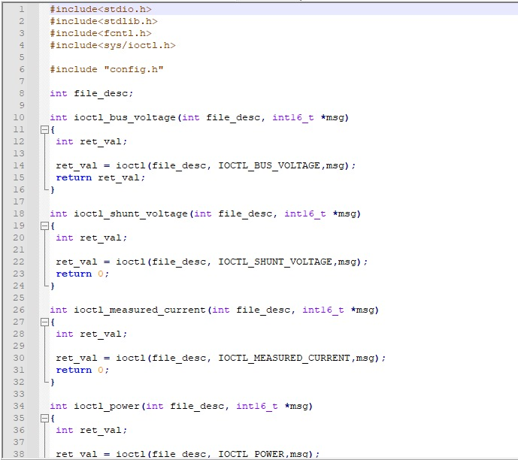

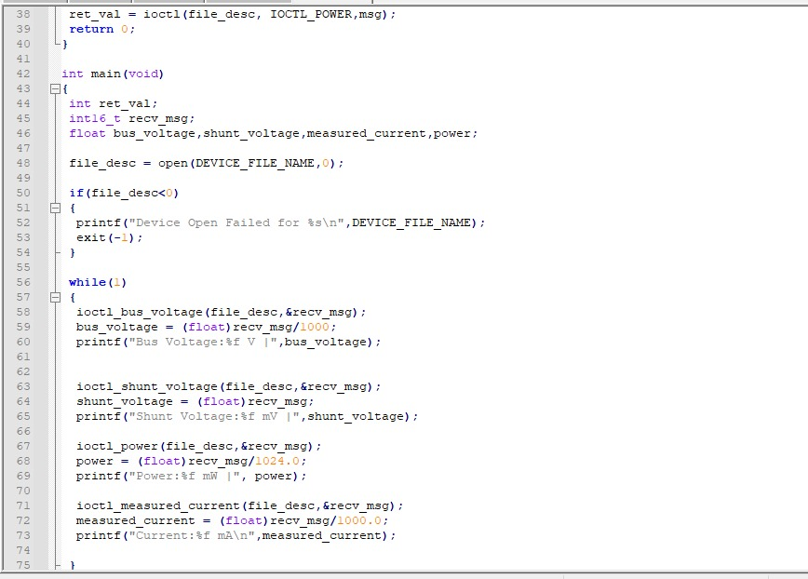

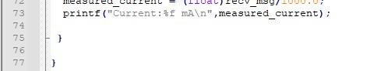

**Build Process :**

* Compile user application code with gcc -o output user.c
* Run the application (sudo ./output) after inserting kernel driver module.

**CONFIGURATION FILE:**

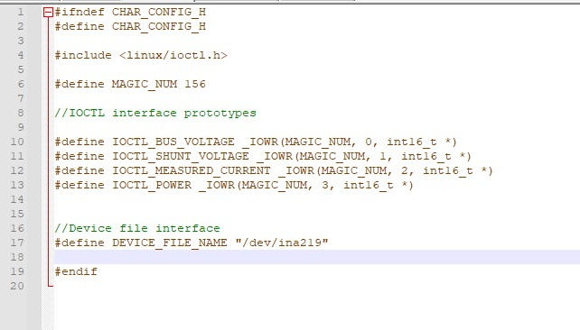

**MAKE FILE:**

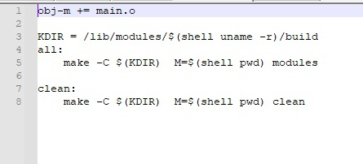

**RESULTS**

In the user space sensed voltage and current values of shunt resistor are being displayed. Bus voltage and power are also being sensed by INA219 sensor and being written into user space.

